**Project Planning Phase**

**Project Planning Template (Product Backlog, Sprint Planning, Stories, Story points)**

|  |  |
| --- | --- |
| Date | 29 june 2025 |
| Team ID | LTVIP2025TMID50169 |
| Project Name | iRevolution A Data-driven Exploration of Apple's iPhone Impact in India using Tableau |
| Maximum Marks | 5 Marks |

**Product Backlog, Sprint Schedule, and Estimation (4 Marks)**

Use the below template to create product backlog and sprint schedule

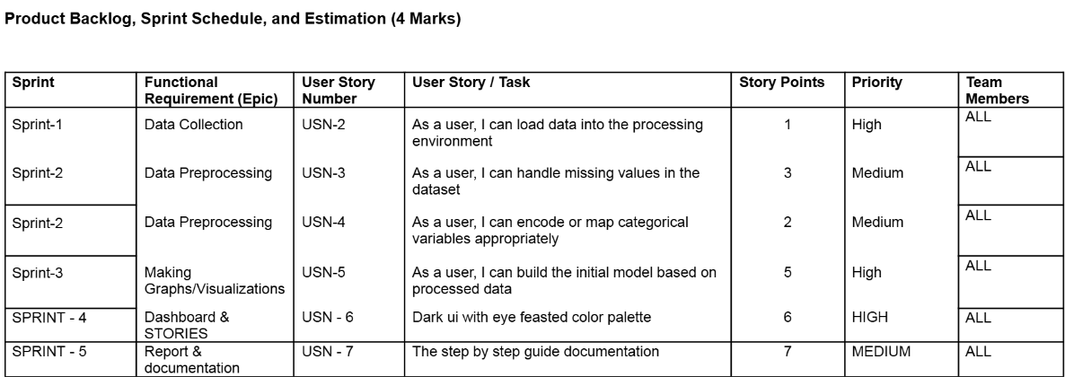

**Project Tracker, Velocity & Burndown Chart: (4 Marks)**

**Velocity:**

Imagine we have a 10-day sprint duration, and the velocity of the team is 20 (points per sprint). Let’s calculate the team’s average velocity (AV) per iteration unit (story points per day)

  
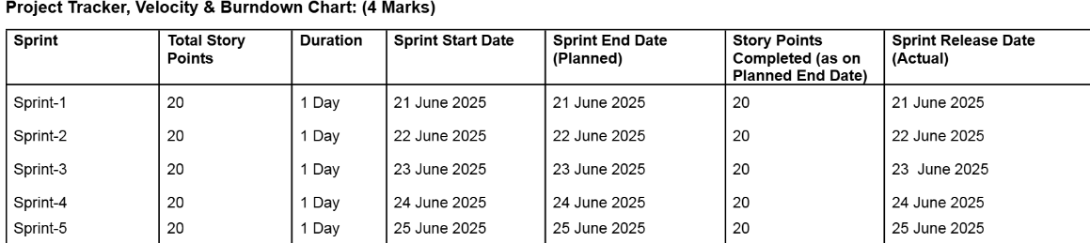

**Burndown Chart:**

A burn down chart is a graphical representation of work left to do versus time. It is often used in agile[software development](https://www.visual-paradigm.com/scrum/what-is-agile-software-development/) methodologies such as [Scrum](https://www.visual-paradigm.com/scrum/scrum-in-3-minutes/). However, burn down charts can be applied to any project containing measurable progress over time.

[**https://www.visual-paradigm.com/scrum/scrum-burndown-chart/**](https://www.visual-paradigm.com/scrum/scrum-burndown-chart/)

[**https://www.atlassian.com/agile/tutorials/burndown-charts**](https://www.atlassian.com/agile/tutorials/burndown-charts)

**Reference:**

[**https://www.atlassian.com/agile/project-management**](https://www.atlassian.com/agile/project-management)

[**https://www.atlassian.com/agile/tutorials/how-to-do-scrum-with-jira-software**](https://www.atlassian.com/agile/tutorials/how-to-do-scrum-with-jira-software)

[**https://www.atlassian.com/agile/tutorials/epics**](https://www.atlassian.com/agile/tutorials/epics)

[**https://www.atlassian.com/agile/tutorials/sprints**](https://www.atlassian.com/agile/tutorials/sprints)

[**https://www.atlassian.com/agile/project-management/estimation**](https://www.atlassian.com/agile/project-management/estimation)

[**https://www.atlassian.com/agile/tutorials/burndown-charts**](https://www.atlassian.com/agile/tutorials/burndown-charts)